Project Guardian - Product Vision
Project Guardian is an AI service that integrates with common SDLC tools such as:
- ✅ Jira
- ✅ Microsoft Teams
- ✅ GitHub
- ✅ Outlook (or shared project mailbox)

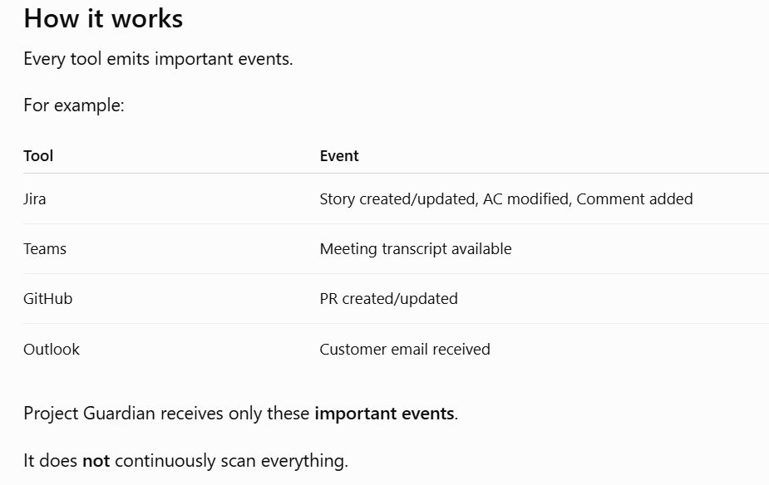
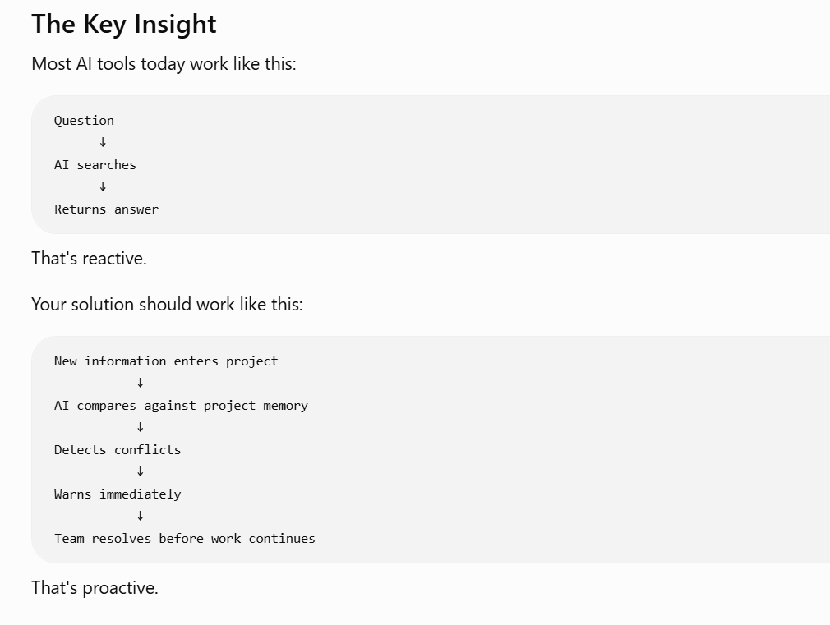

The Three Problems It Solves
1. Lost Decisions
Important project decisions disappear inside meetings, chats, or emails and are forgotten later.

2. Duplicate Conversations
Teams repeatedly discuss questions that were already answered because nobody knows the decision already exists.

3. Decision Drift
New requirements, comments, or documentation gradually diverge from previously approved business decisions without anyone noticing.

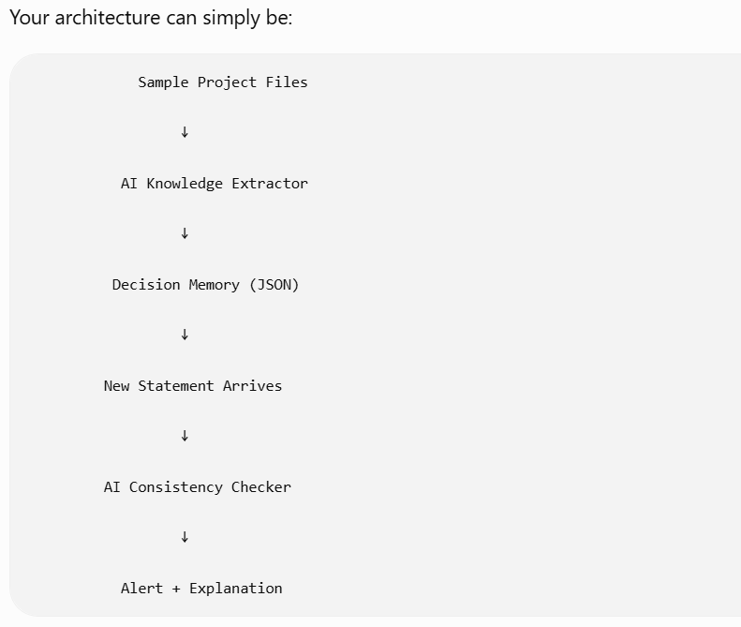

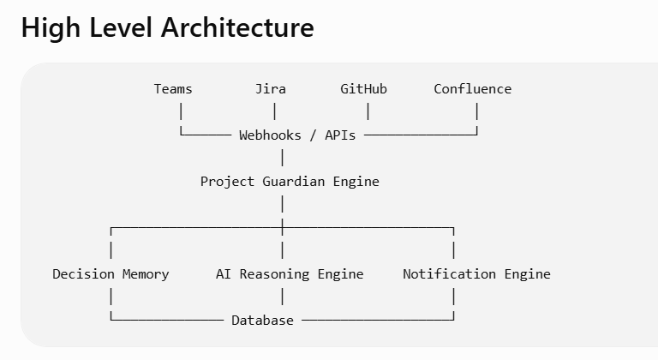

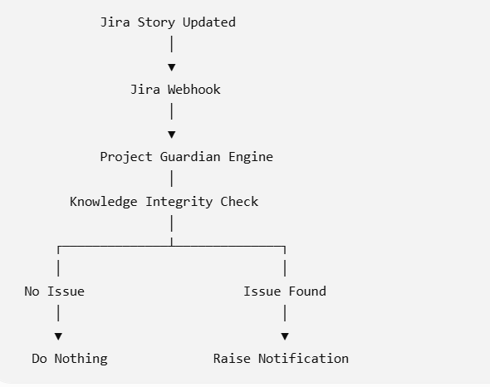

Project Guardian is event-driven. It subscribes to significant project events from tools like Jira, GitHub, Teams, and Confluence. Each event is evaluated by the AI Knowledge Engine, which decides whether to ignore it, log it, or intervene based on the risk to project knowledge integrity.

There is no separate Project Guardian application.
Guardian appears inside the workflow
- In Jira, it's an inline warning beside the story.
- In GitHub, it's a PR comment or merge check.
- In Teams, it's a message in the meeting chat.
- In Outlook, it could flag the email as requiring project review.
The AI engine is the same, but the way it intervenes is native to the user's workflow

